**NODEJS ELASTICSEARCH INTEGRATION**

An application that used to connect Elasticsearch instance and can be able to do several operations like create and delete an index, also we can be able to create, read, update, delete and search documents in elastic index using NodeJS.

**Prerequisites:**

* The following software that needs to be installed before the execution.
  + Elasticsearch
  + Kibana
  + NodeJS
* Download the project Movie_Hunt--React-Node-Elastic.zip folder and extract the same on local.

**Installation Steps:**

1. Install Elasticsearch by following this [link](https://www.elastic.co/guide/en/elasticsearch/reference/current/zip-windows.html).
2. Install Kibana by following this [link](https://www.elastic.co/guide/en/kibana/current/windows.html).
3. Install NodeJS by downloading [here](https://nodejs.org/dist/v16.16.0/node-v16.16.0-x64.msi) and follow the instructions on the wizard.
4. Open **cmd** in the extracted project directory and give the npm install command to download all the required node modules required for the NodeJS project execution.

Movie_Hunt--React-Node-Elastic\nodejs-elastic-integration\npm install

1. Again, open another **cmd** in the extracted project directory and give the npm install command to download all the required node modules required for the ReactJS project execution.

Movie_Hunt--React-Node-Elastic\npm install

**Execution Steps:**

1. After the installation of required software and packages listed above, navigate to the elasticsearch installed folder and run the Elastic instance.

elasticsearch-7.14.0\bin\elasticsearch.bat

1. Wait for the elastic instance get started running and check the elastic instance is up or not by using this URL (<http://localhost:9200/>) in the browser.
2. Navigate to the kibana installed folder and run the Kibana instance after the elastic instance is up.

kibana-7.14.0-windows-x86_64\bin\kibana.bat

1. Wait for the kibana instance get started running and check the kibana instance as well by using the URL (<http://localhost:5601/>) in the browser.
2. Navigate to this path in a **cmd** and execute this file in the terminal to create an index in Elasticsearch.

Movie_Hunt--React-Node-Elastic\nodejs-elastic-integration>node create.js

1. After creating the index, just start the NodeJS server application in the specified path.

Movie_Hunt--React-Node-Elastic\nodejs-elastic-integration\npm start

1. After that, run our ReactJS application in the specified path and type y and press Enter key, when the prompt asked for yes or no to run the application on different port.

Movie_Hunt--React-Node-Elastic\npm start

**Utility Details:**

Run these files using the command node filename.js in the **cmd** at the located path(Movie_Hunt--React-Node-Elastic\nodejs-elastic-integration).

1. connection.js - Used to create a connection with Elasticsearch.
2. create.js - Used to create an index in Elasticsearch.
3. delete.js - Used to delete an index from Elasticsearch.
4. info.js - Used to get the cluster health status and the no. of documents in a particular index.
5. movies_bulk_document_add.js - Used to ingest the dummy data defined in the movies.json file to elastic index.
6. movies.json - Having sample data to ingest into elastic index using the utility.
7. search.js - Having various endpoints that will do the operations like search, create, read, update, and delete a document in the elasticsearch.

**Application Workflow:**

1. Once our application gets started, we can be able to see our react application is running on this URL (<http://localhost:3001/>) in the browser.

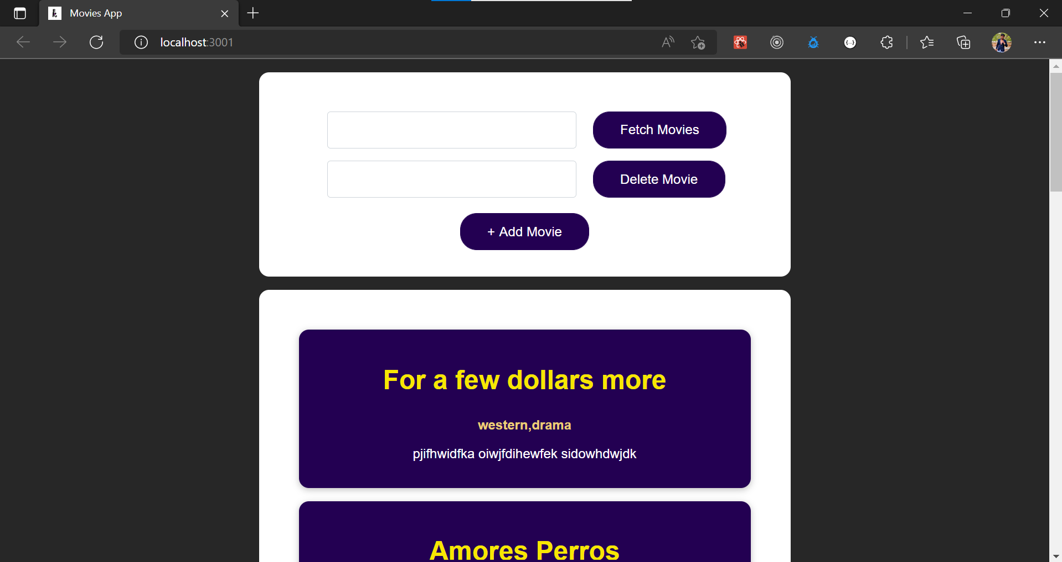

1. Click on Add Movie button and enter some data, then click on Add button in the form. After clicking on Add, it will store the data by creating a document (record) inside the elastic index.

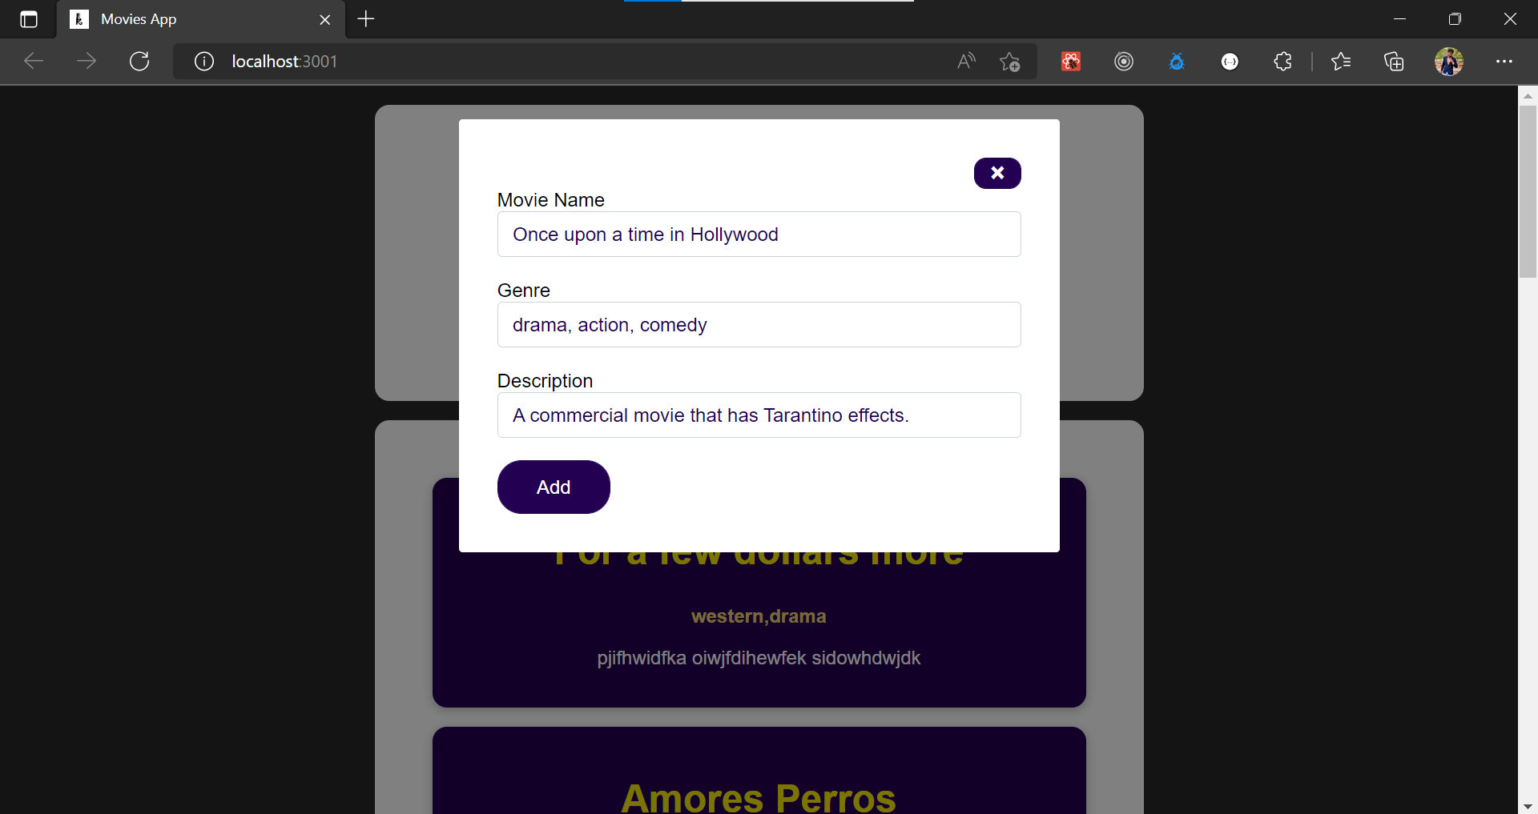

1. Now search for that movie created using the text box and click on Fetch Movies button.

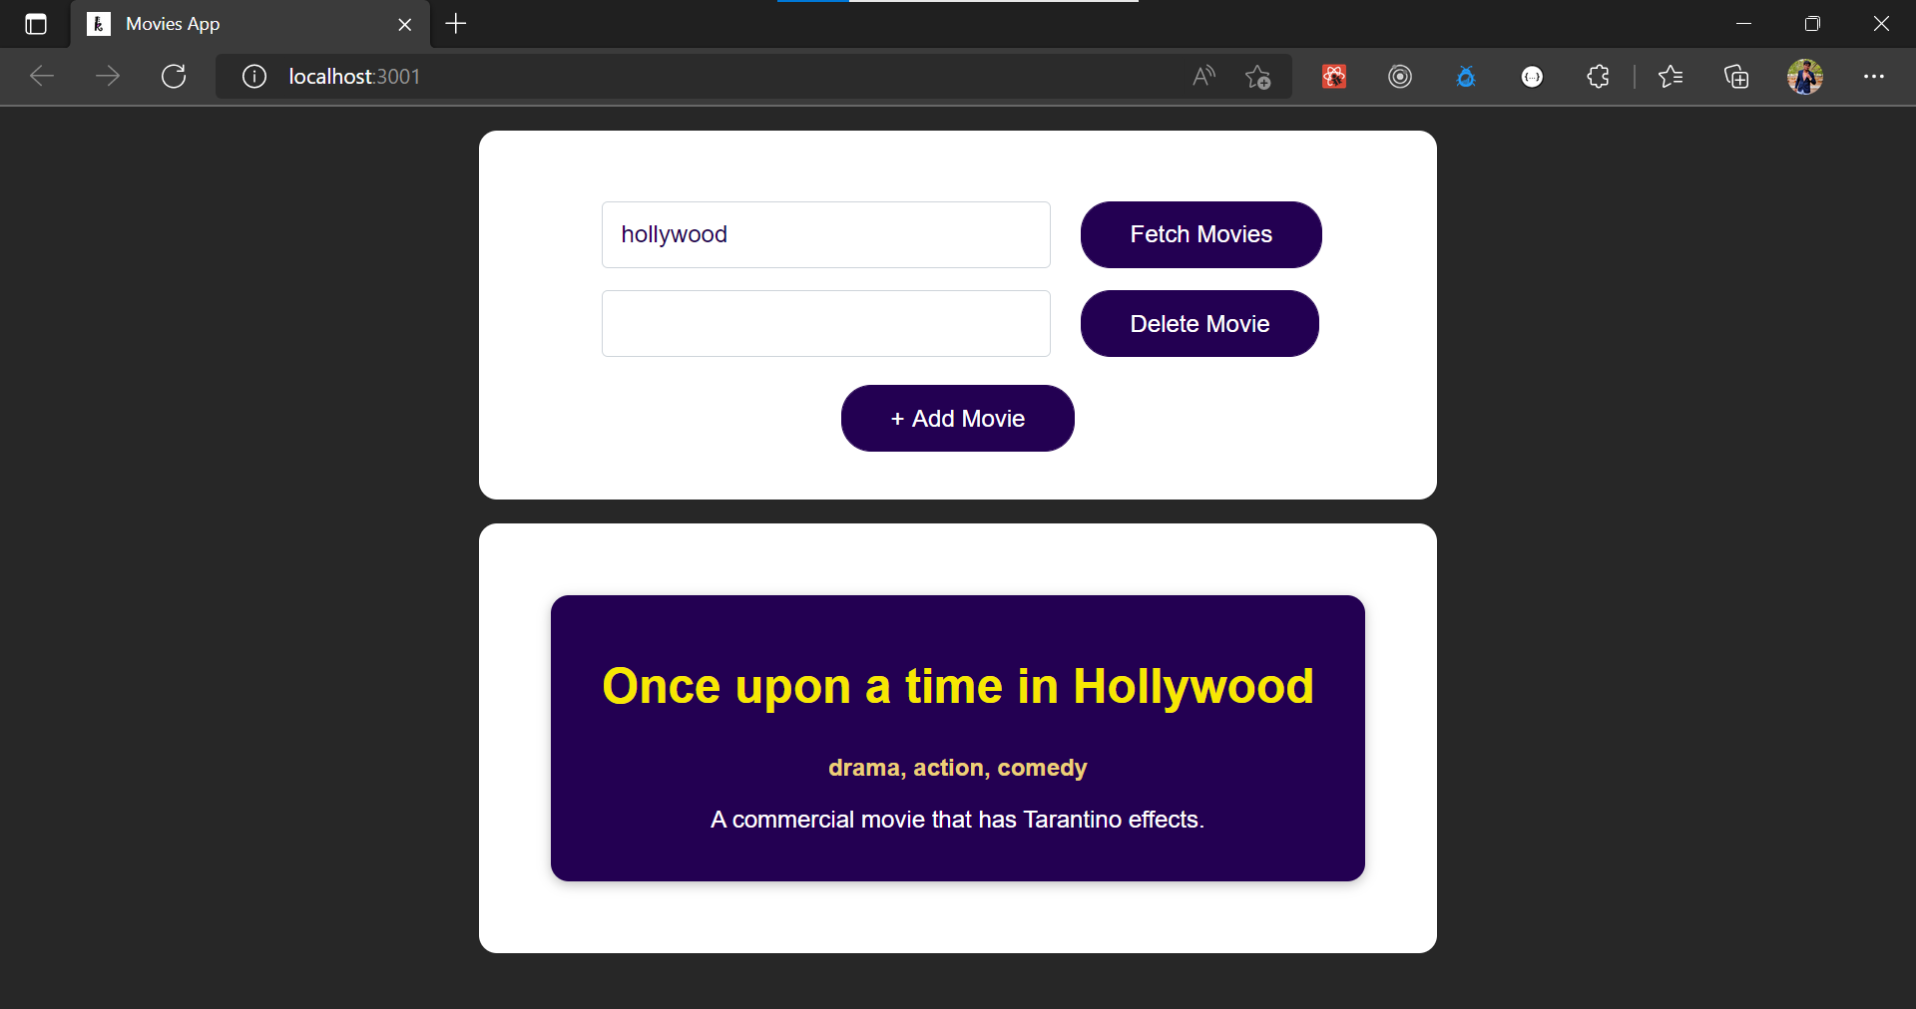

1. Get the movie id in the Kibana portal by searching the index.

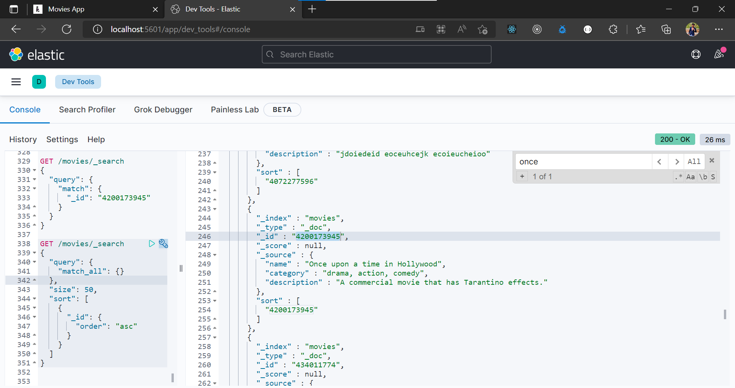

1. Paste that movie id in the text box and click the Delete Movie button.

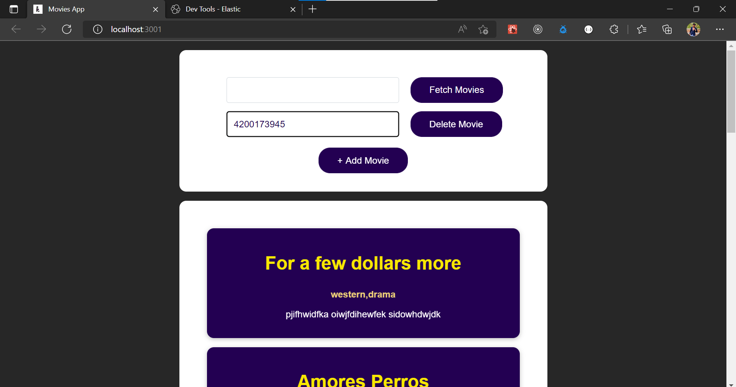

1. It will give the acknowledgement and deletes that movie from the elastic index.

